|  |  |  |  |
| --- | --- | --- | --- |
| Name:  Class: | ____________________________________  ________________ | | Date: ___________ |
|  | **Year 11 Essential Mathematics Unit 2**  SCORE:  / 19    **Mini Test 2.7 2018**  **Topic – Distance, Length and Speed**  ***Full working out MUST be shown to get full marks for each question.*** | | |
| **Total Time:** | 30 minutes |  | |
| **Weighting:** | 1% |
| **Equipment:** | To be provided by the student: Pen, pencil, ruler, scientific calculator,1 single sided page of A4 notes | | |

**Question 1. [2 marks]**

Cheetahs can run at a speed of 35 m/s making them the fastest land animal.

1. How far can a cheetah run in 8 seconds?
2. You want to out run the cheetah, it takes you 55 seconds to run 140m. How long does it take the cheetah to run 140m? Answer in seconds and round to 1 decimal place.

**Question 2 [5 marks]**

Jade travels from her home to Fremantle to go to work. The graph shows the distance Jade was from Fremantle as she travelled to work on Friday. Jade left home at 9:00 am to drive to Fremantle. She stopped at a café for a quick breakfast with her friend Aden. After breakfast, Jade dropped Aden back at his house before she continued her journey to work.



1. What was Jade’s average speed on the way to the café in km/h?
2. How long did Jade and Aden take to have breakfast?
3. At what time did they leave the café?
4. How far does Aden live from the café?
5. After dropping off Aden, what was Jade’s average speed on the way to Fremantle in km/h?

**Question 3 [2 marks]**

Steve completed a test answer where he calculated the following speeds. However for each answer he forgot to include the units.  Write down what units you think these answers should have,

1. A boat travels at 15 _________
2. A car travels at 60 _________
3. An airplane travels at 350 ___________
4. A sprinter runs at  23___________

**Question 4 [3 marks]**

The scale is 1 : 1000. Calculate the real life-lengths of each feature on the map:

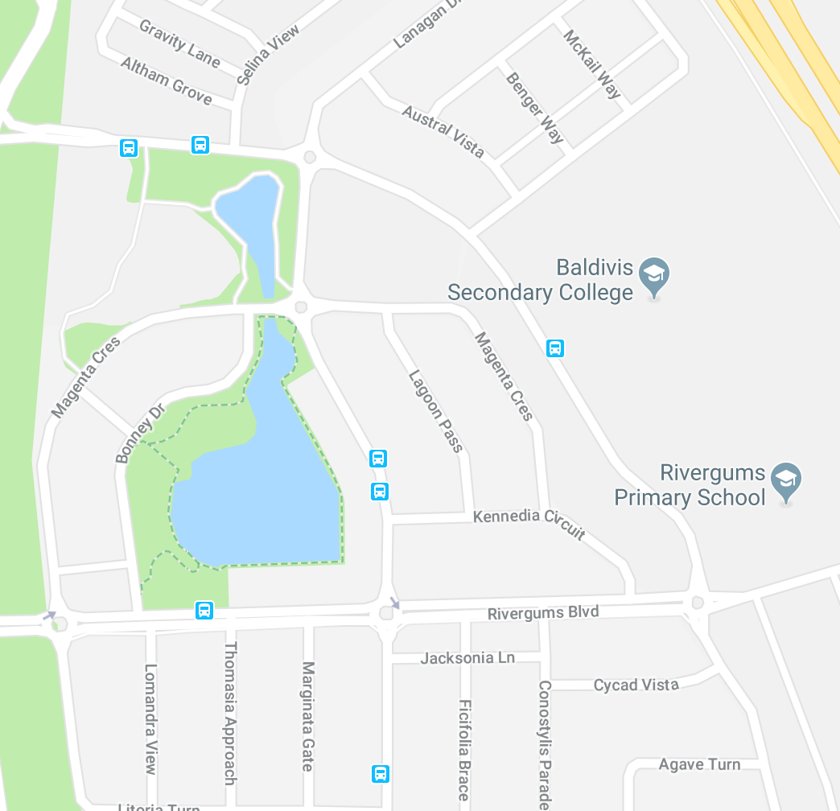

1. The width of the lake
2. If Tommy walks at a speed of 5m per minute, how long did it take him to walk to school?

**Question 5 [7 marks]**

Draw a travel graph using the following story:

Jasper was training for a Grit Race. He likes to get up at 5am and spend 15 minutes warming up on a yoga mat in his room. He then goes for a 10km run at a speed of 200m/min heading in a straight line away from home. Jasper gets to a park that has some monkey bars. He spent 10 minutes doing some pull-ups and sit-ups. He then runs at a speed of 250m/min for 20 minutes to Brother of Mine that is on the way home for a coffee.



1. How long did it take Jasper to run the 10km?
2. What time did he get to Brother of Mine?

**End of Test**